A picture containing clipart

Description generated with very high confidence

Azure 103

Project Solution

[**support@intellipaat.com**](mailto:support@intellipaat.com)

**+91-7022374614**

**US: 1-800-216-8930(Toll Free)**

**AZ - 103**

**Project Solution.**

**Issue #1: They wish to have a centralized store to store all their developer tools in. This store should be such that developers can mount it on their file system.**

**Solution:**

**Step 1:** Create and open your storage account.

**Step 2:** Click on Files.

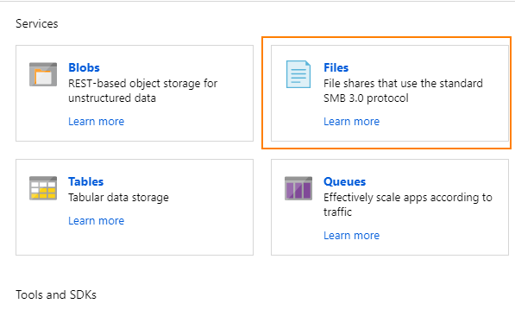

**Step 3:** Click on + FileShare.

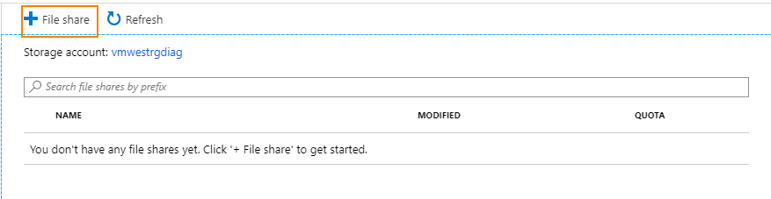

**Step 4:** Enter details and click create.

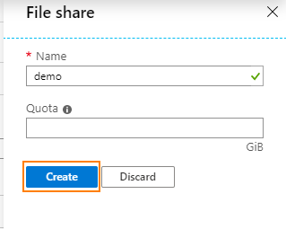

**Step 5:** Mount the File Share on you PC.

**Step 5.1:** Open the File Share in Azure Portal.

**Step 5.2:** Click on connect.

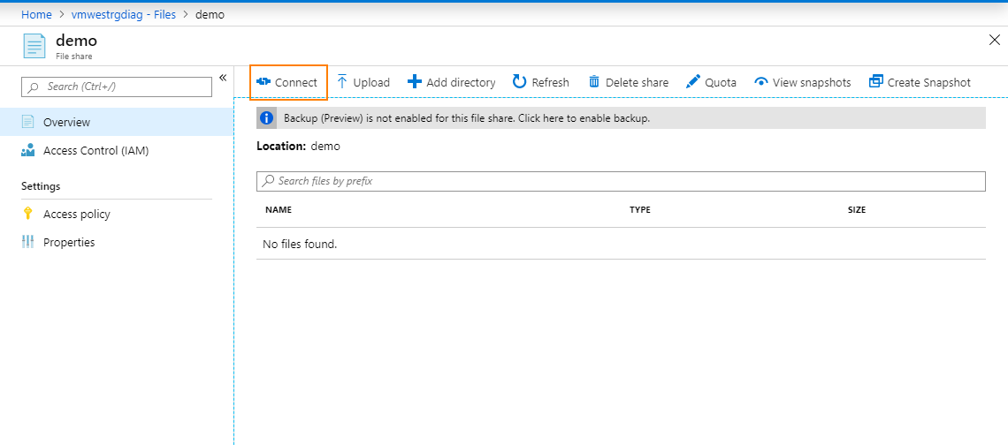

**Step 5.3:** Copy the command and check you have URL, Username and Password.

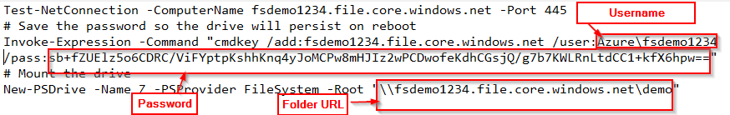

**Step 5.4:** Open Windows Explorer.

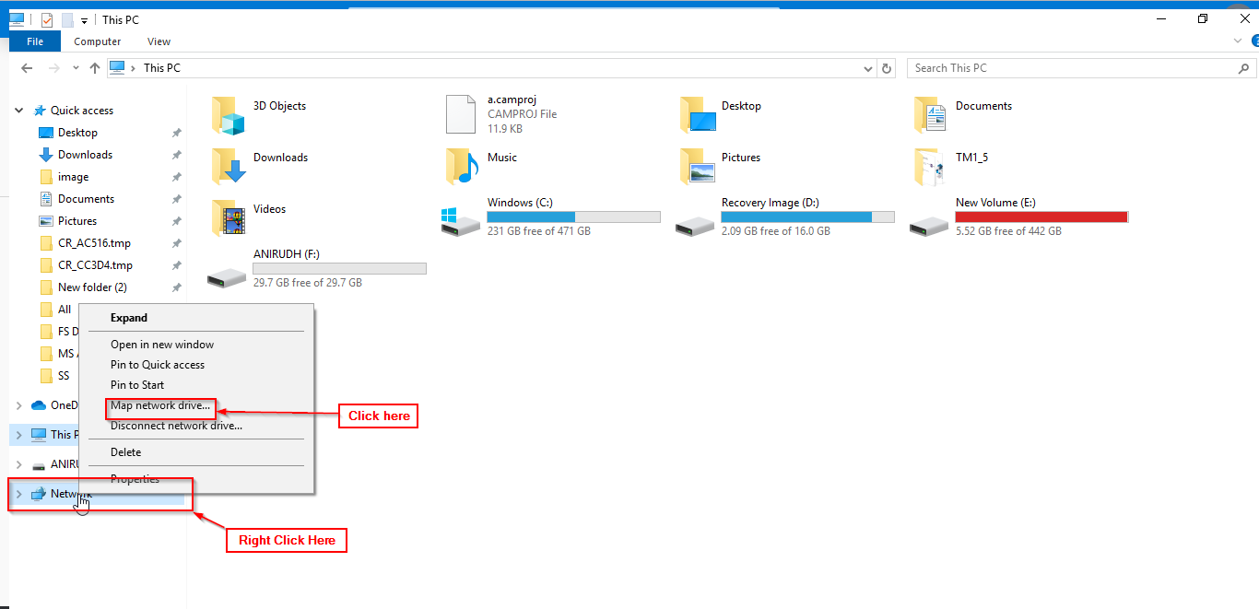

**Step 5.5:** Right Click on Network and Select Map network drive.

**Step 5.6:** In the folder section paste the URL copied from the command.

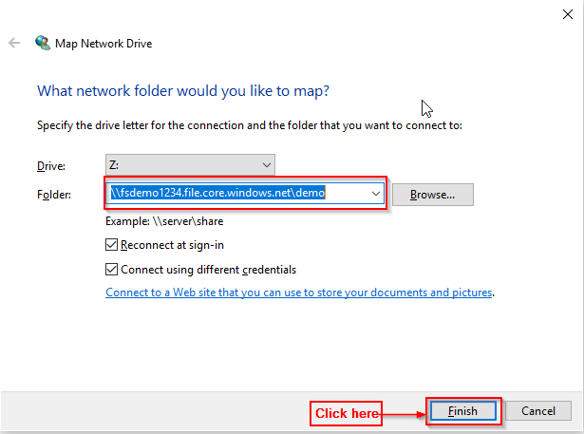

**Step 5.7:** Enter username and password from the command and click OK.

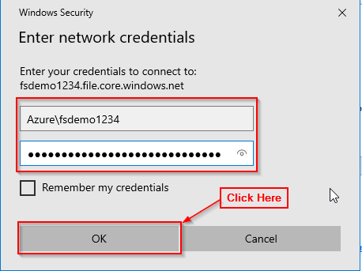

**Issue #2: They wish to store large volume of image data. They wish to have low latency access to frequently accessed images i.e. images that have been accessed in the last 14 days. If an image is not accessed within the last 14 days they wish to archive them.**

**Solution:**

**Step 1:** Create a blob container.

**Step 2:** Add images to that blob.

**Step 3:** Under Blob Service in the sidebar, select Lifecycle management.

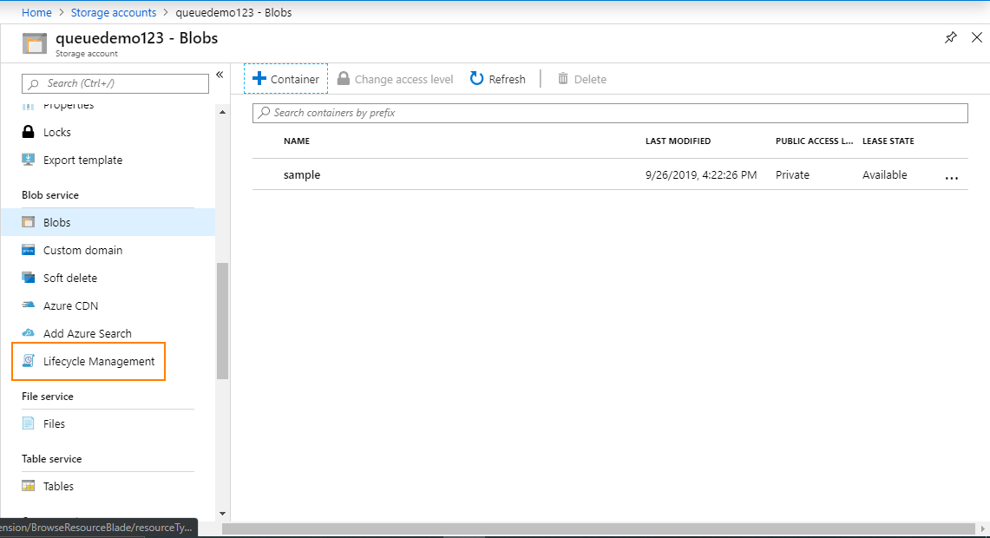

**Step 4:** Select Add rule.

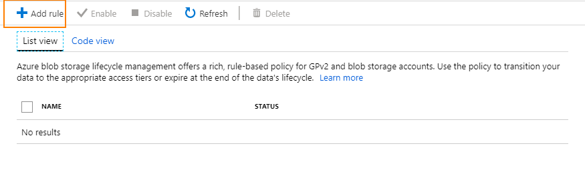

**Step 5:** Under the action set tab fill in the following details.

**Step 5.1:** Add rule name.

**Step 5.2:** Select Move blob to archive storage.

**Step 5.3:** In Days after last modification fill 14.

**Step 5.4:** Click on Review + Add.

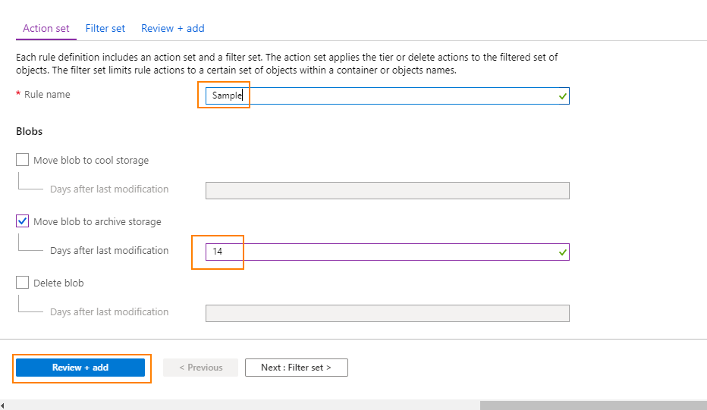 **Step 5.4:** Click on Add.

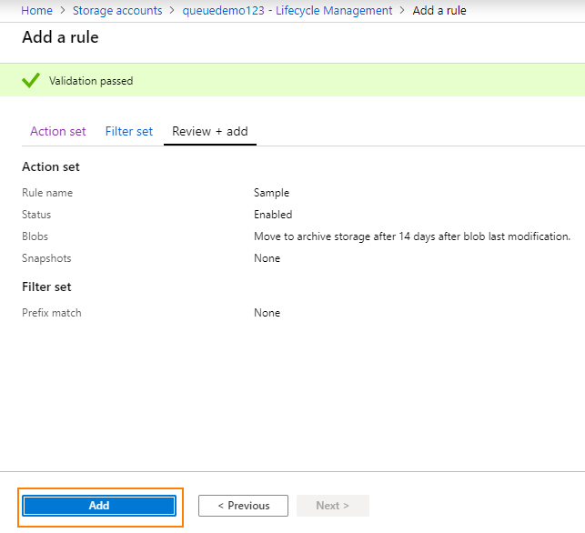

**Issue #3: They wish for lower the latency of their website, they have noticed that users who are far away from their web server have complained that images take a lot of time to load.**

**Solution:**

**Step 1:** Create a storage account for Blob Storage and upload a few images.

**Step 2:** In the Azure Portal’s search for CDN Profiles and open it.

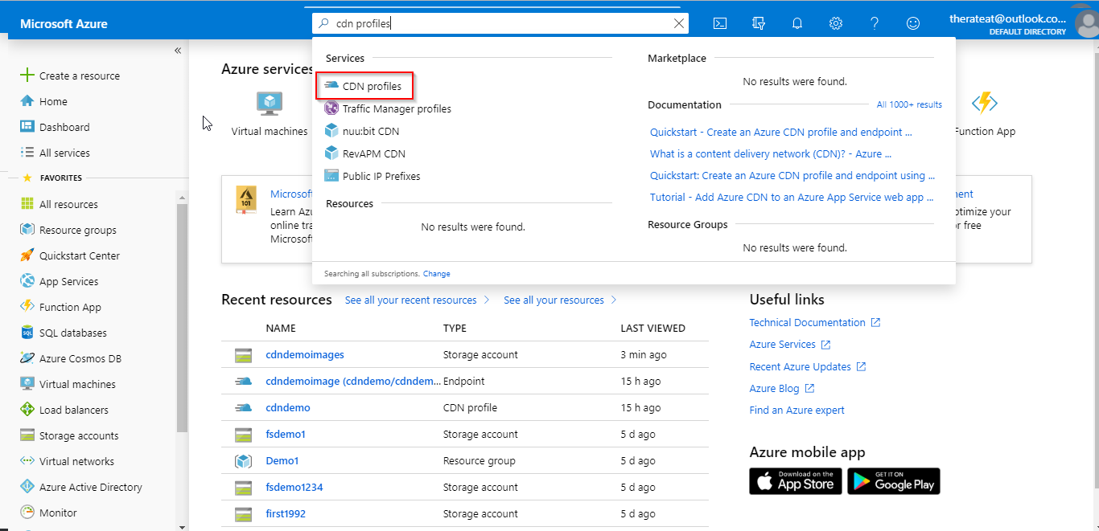

**Step 3:** Click on ‘+ Add’.

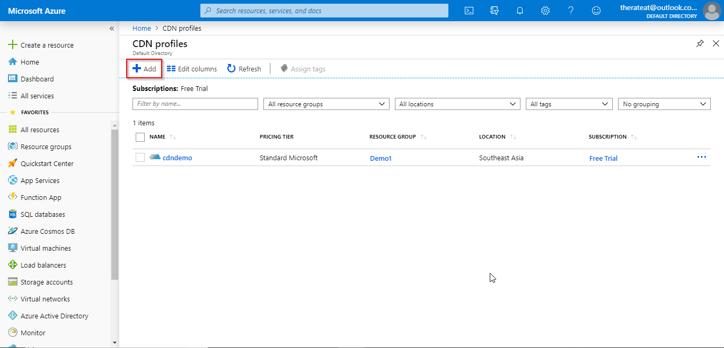

**Step 4:** Fill the details and click on create.

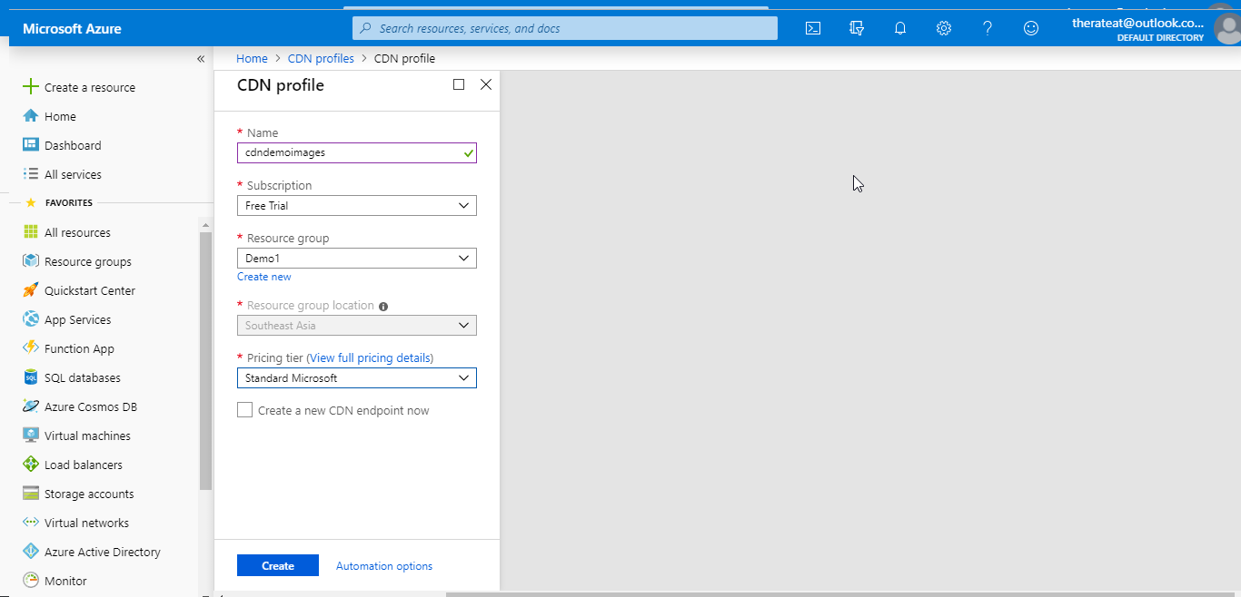

**Step 5:** Click on the CDN Profile just created.

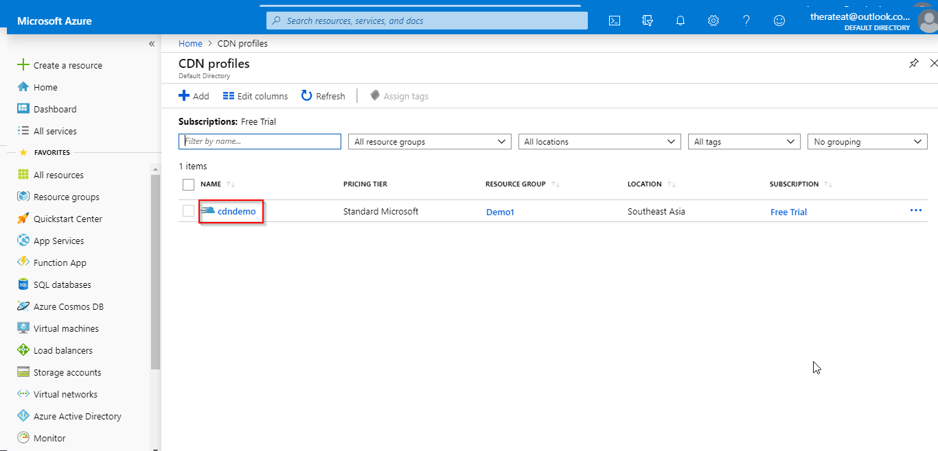

**Step 6:** Click on the ‘+ Endpoint’.

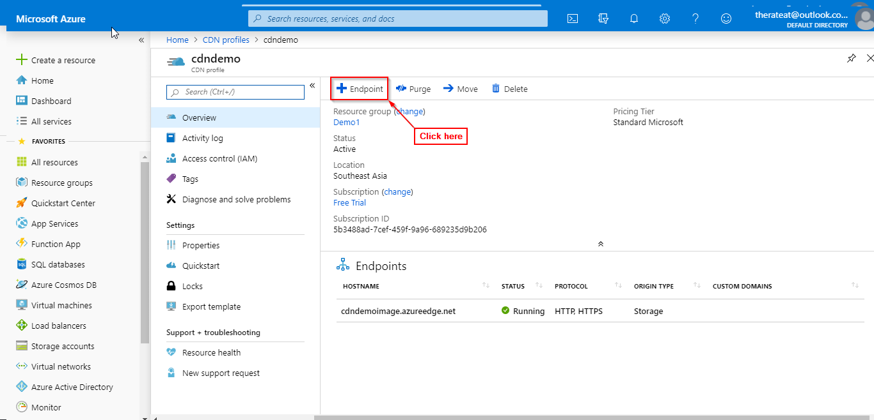

**Step 7:** Enter the details:

* Origin type : Storage
* Origin hostname : URI of BLOB storage created in previous step

**Step 8:** Click on add.

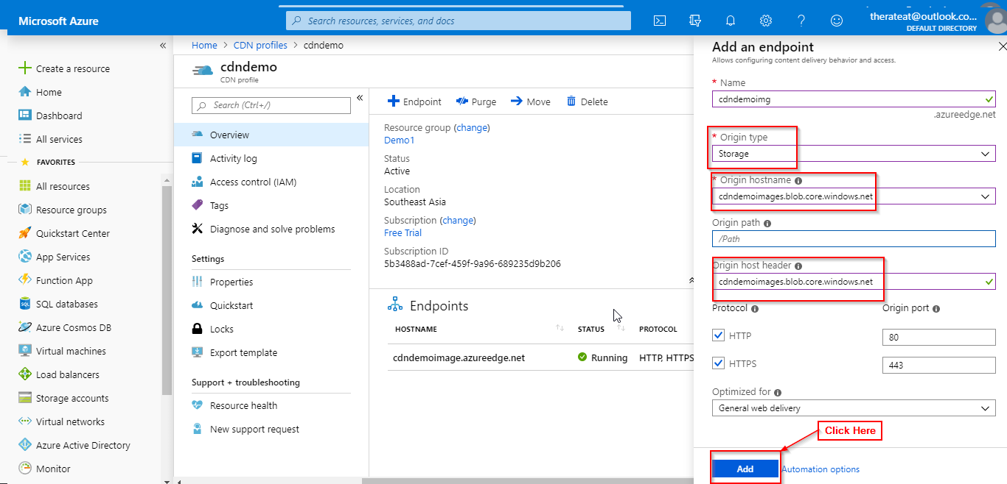

**Issue #4: They wish to serve another website on azures VM's.**

**Solution:**

**Step 1:** Create a VM using Azure Portal (Make sure to enable HTTP and RDP protocol for connecting).

**Step 2:** Open the VM using RDP.

**Step 3:** Open Server Manager.

**Step 4:** Click on 'Add Roles and Features'.

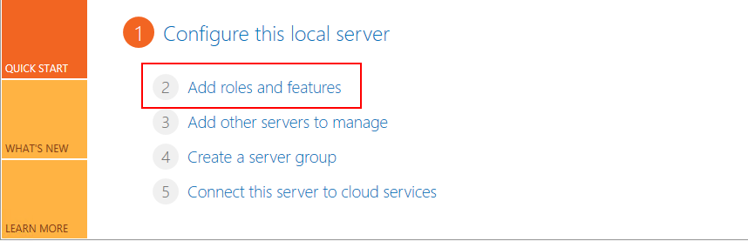

**Step 5:** In the wizard click on 'Next' 3 times and then in 'roles' select Web Server (IIS).

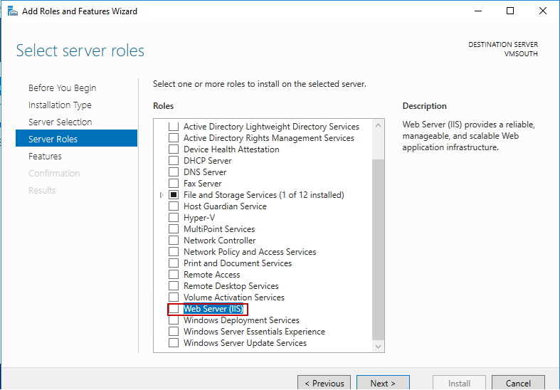

**Step 6:** Click on Next and Install.

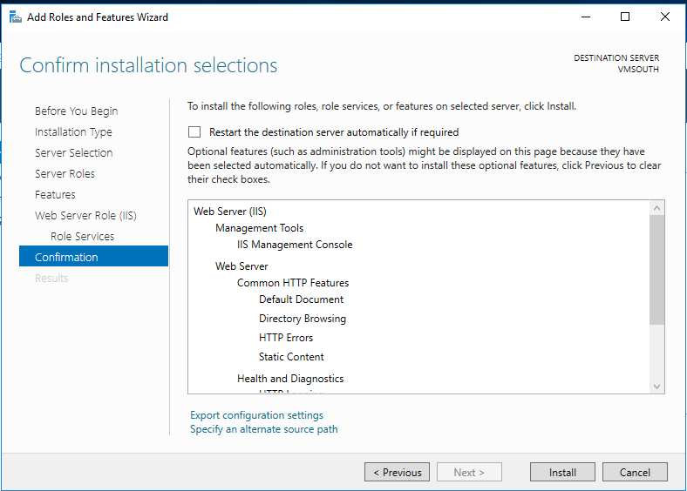

**Step 7:** After installation finishes Open ‘C:\inetpub\wwwroot\’ ,this is the root folder of IIS.

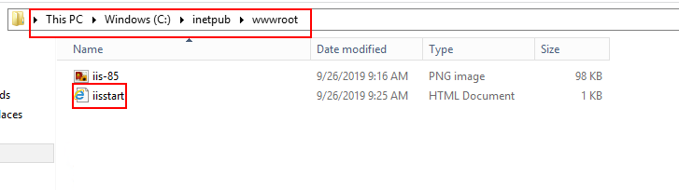

**Step 8:** Open iisstart.html in notepad.

**Step 9:** Make changes to the code by replacing the body tag with following code and save it.

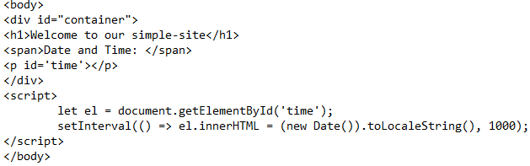

**Step 10:** Open localhost in Internet Explorer in VM to see if it works.

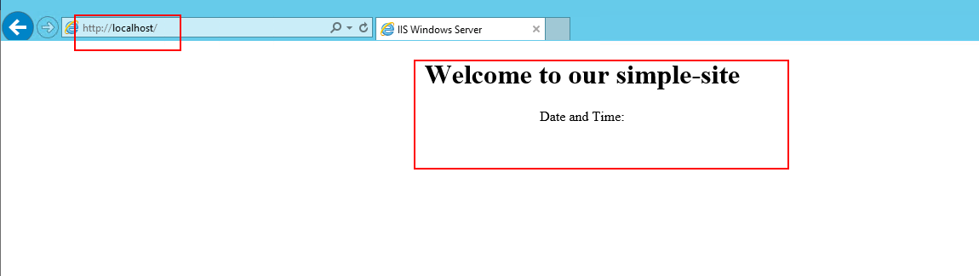

**Step 11:** Open the VM page in Azure Portal.

**Step 12:** Copy the public IP Address of the VM and open in in the browser.

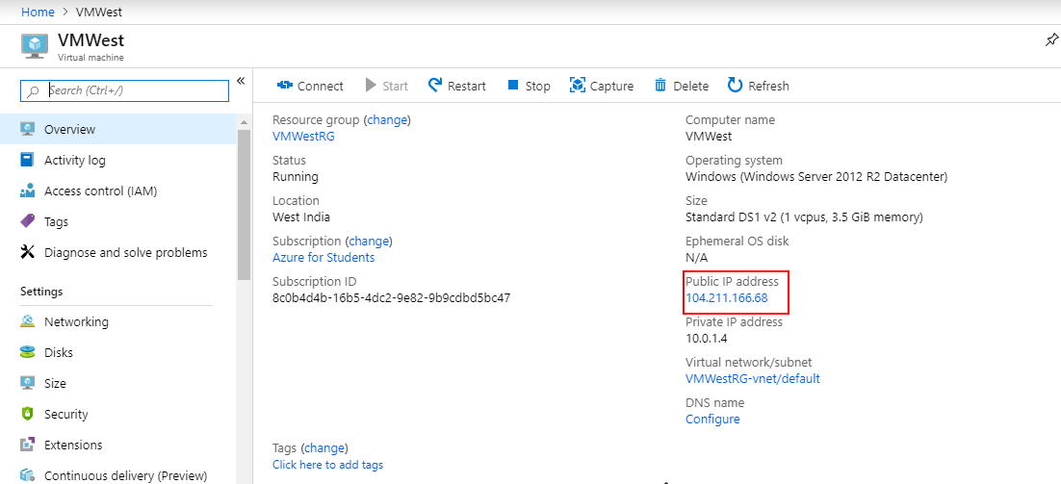

**Step 13:** See that your simple-site is being served by the web server.

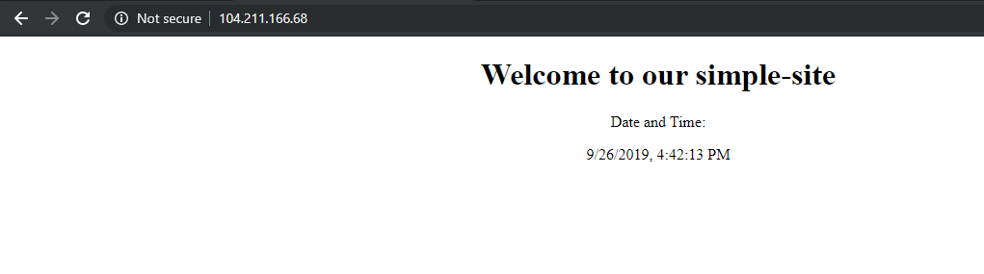

**Issue #5: They also want to have two VM's in different networks, they wish for you to deploy those VM's and enable communication between them.**

**Solution:**

**Step 1:** Create Two VNets in the same region.

**Step 2:** Create two VM's, one in each separate VNET.

**Step 3:** Open Virtual Network page in Azure Portal.

**Step 4:** Click and open one of the VNets created in Step 1.

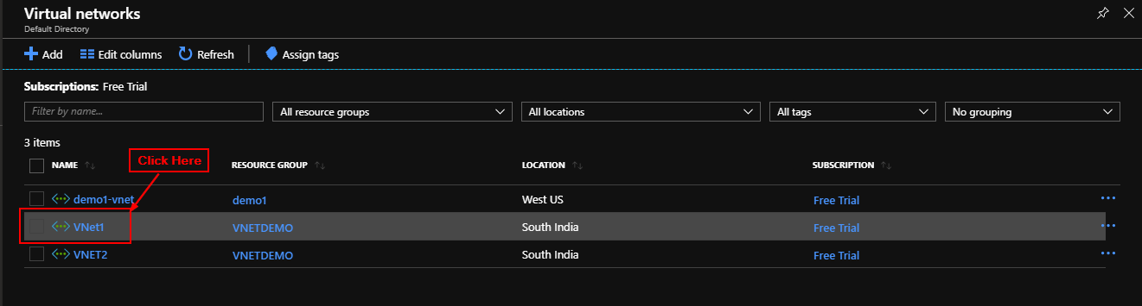

**Step 5:** In the sidebar click on Peerings.

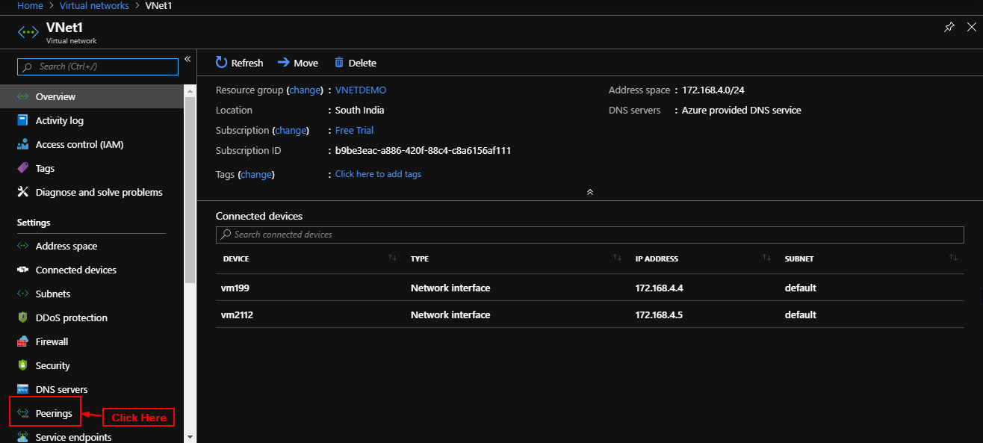

**Step 6:** Click on + Add.

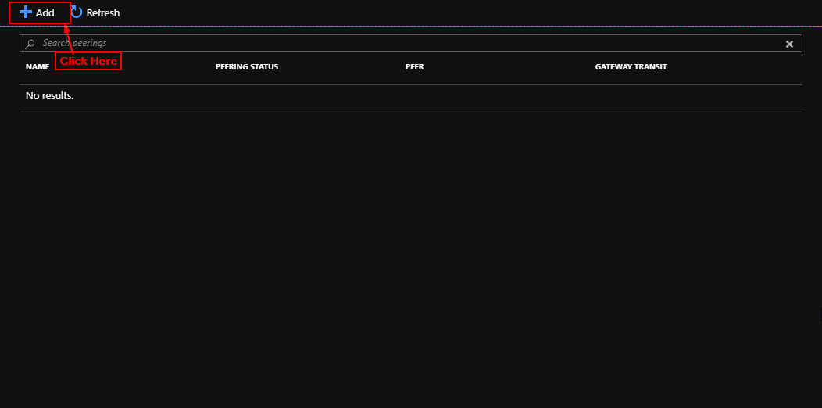

**Step 7:** Enter the details, make sure you add details for both peerings to enable bi-directional communication.

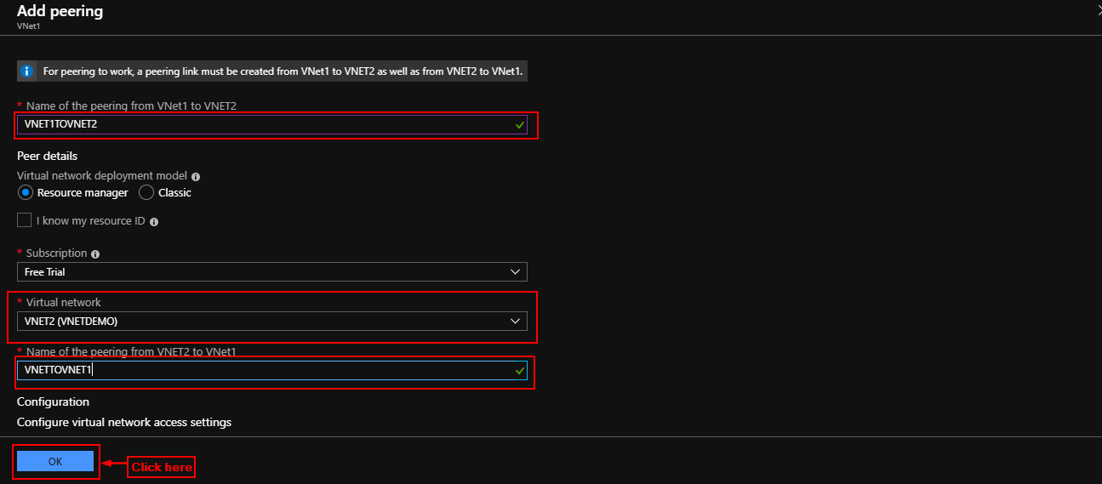

**Step 8:** Click on OK.

**Issue #6: They wish to use azure to resolve their site with domain a domain of your choice to its IP address.**

**Solution:**

**-- GET A FREE DOMAIN --**

**Step 1:** Open and sign up at freenom.com

**Step 2:** Buy a free domain (for our purposes it can be anything).



**-- Configure Azure DNS –**

**Step 1:** In Azure portal search for DNS Zones and open it.

**Step 2:** Click on + Add.

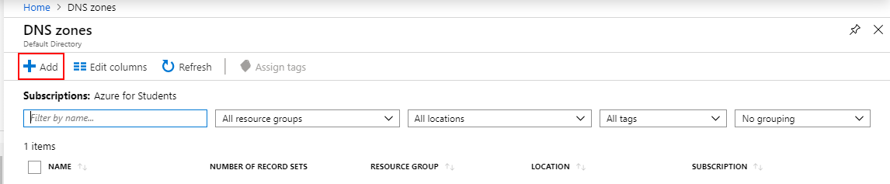

**Step 3:** Enter the following details and click on ‘Review + Create’.

* Resource Group: Your Resource Group.
* Name: you domain name e.g ‘simple-site.ml’.

**Step 4:** Click on Create.

**Step 5:** Open the DNS Zone and copy Name Server Addresses.

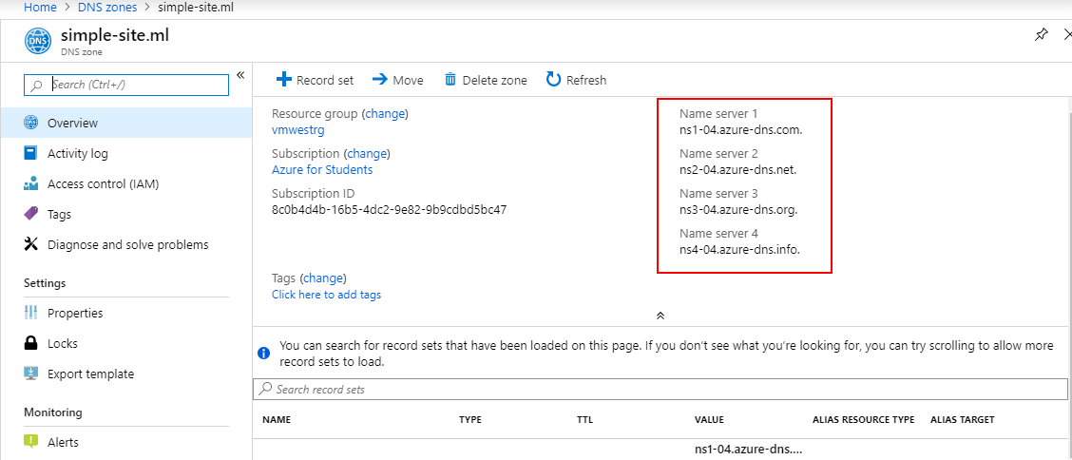

**Step 6:** Open your domain name provider's admin panel.

**Step 7:** Change the name server addresses to the azure NameServers.

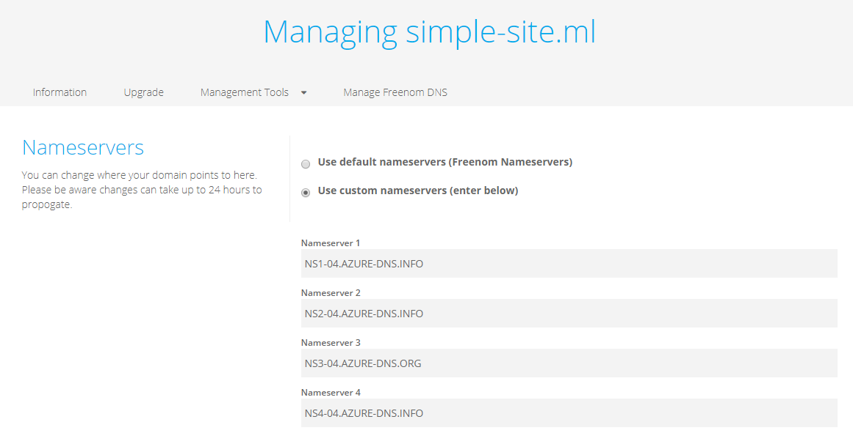

**Step 8:** Open the DNS Zone and click on ‘+ Record Set’.

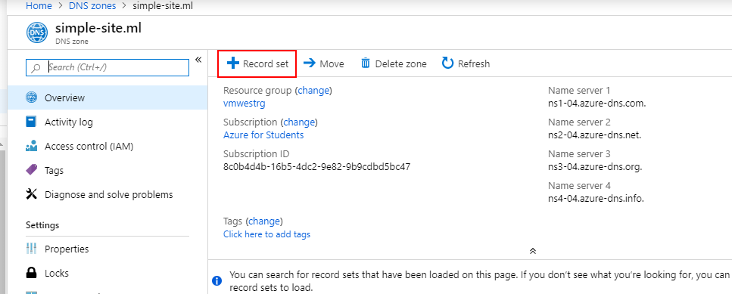

**Step 9:** Enter details:

- **Name**: www.

- **Type**: A

- IP Address as the Public IP of the VM on which app is deployed (Public IP of VM Created in solution of issue #4).

**Step 10:** Click on ‘OK’.

**Step 11:** Now open the domain.

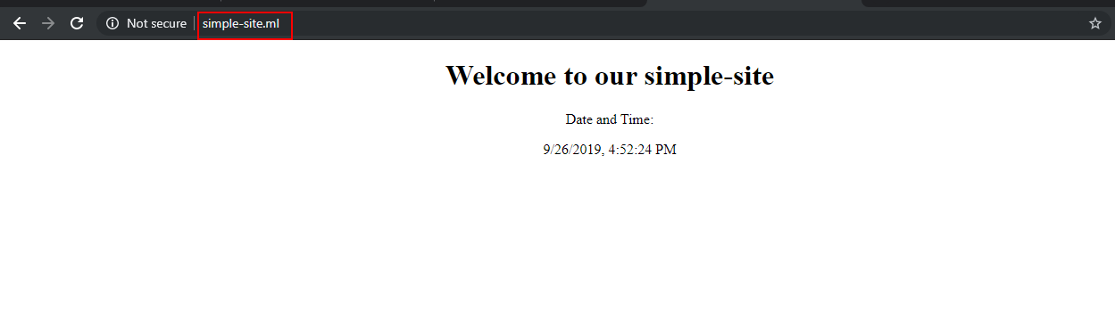

**Issue #7: They wish for both the VM's serving their website to be more reliable so that if one VM fails the traffic is automatically routed to the other one.**

**Solution:**

**Step 1:** Create two virtual machines within a single availability set and same virtual network.

**Step 2:** Search Load Balancer in Azure Portal and click on it.

**Step 3:** Click on ‘+ Add’.

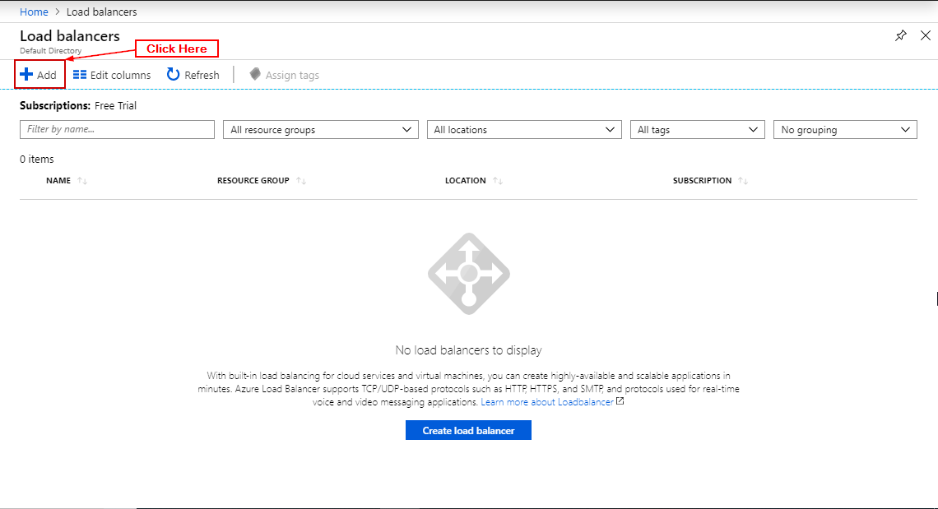

**Step 4:** Add details and click ‘Review + Create’.

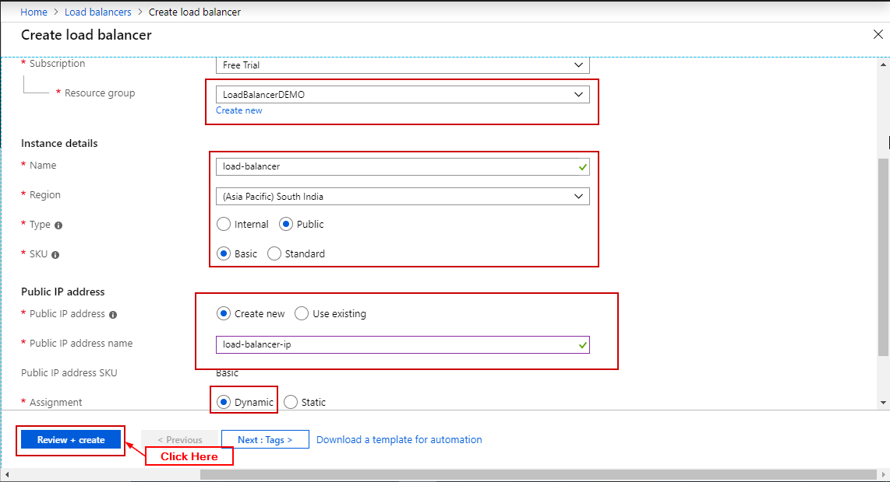

**Step 5:** Click on 'Create'.

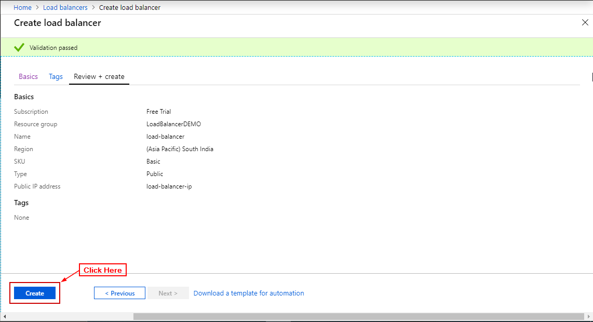

**Step 6:** Open the load balancer.

**Step 7:** Click on backend pools and click on ‘+ Add’.

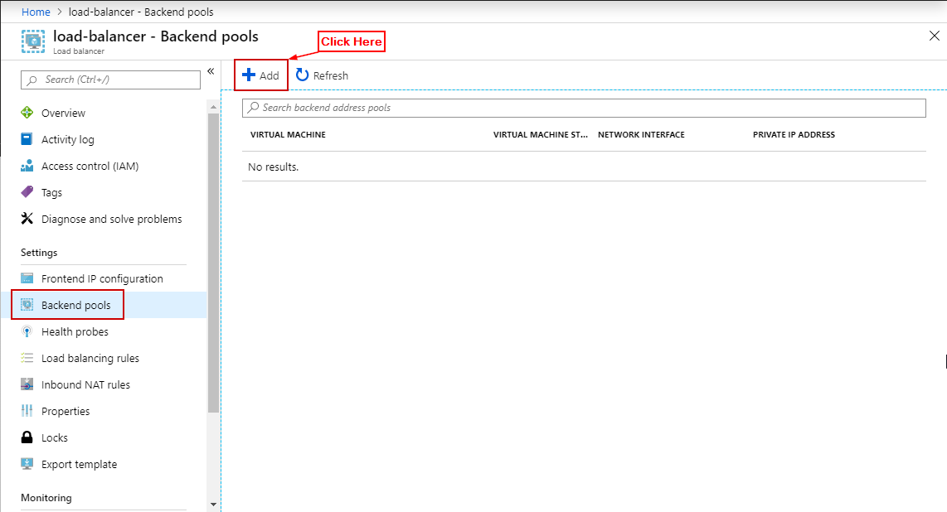

**Step 8:** Enter the details (Availability Set, in target IP Configuration add both VM’s and their IP) and click on OK.

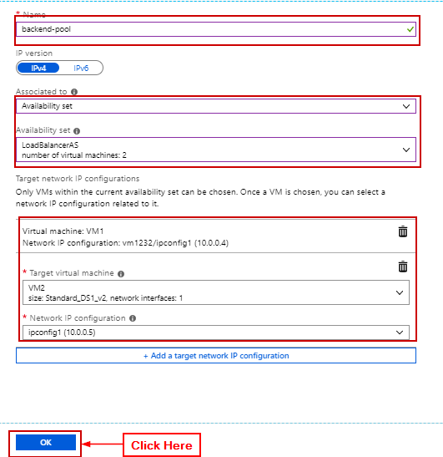

**Step 9:** In load balancer click on health probes and click on ‘+ Add’.

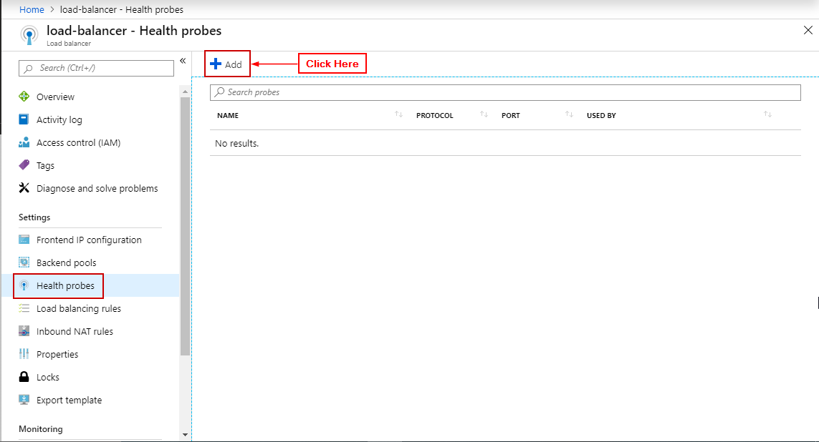

**Step 10:** Enter details click on OK.

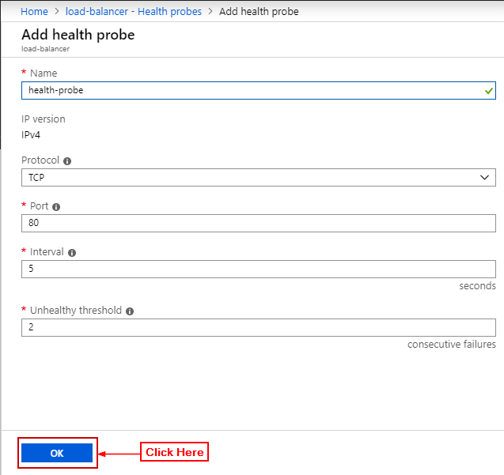

**Step 11:** In load balancer click on Load Balancing Rule and click on ‘+ Add’.

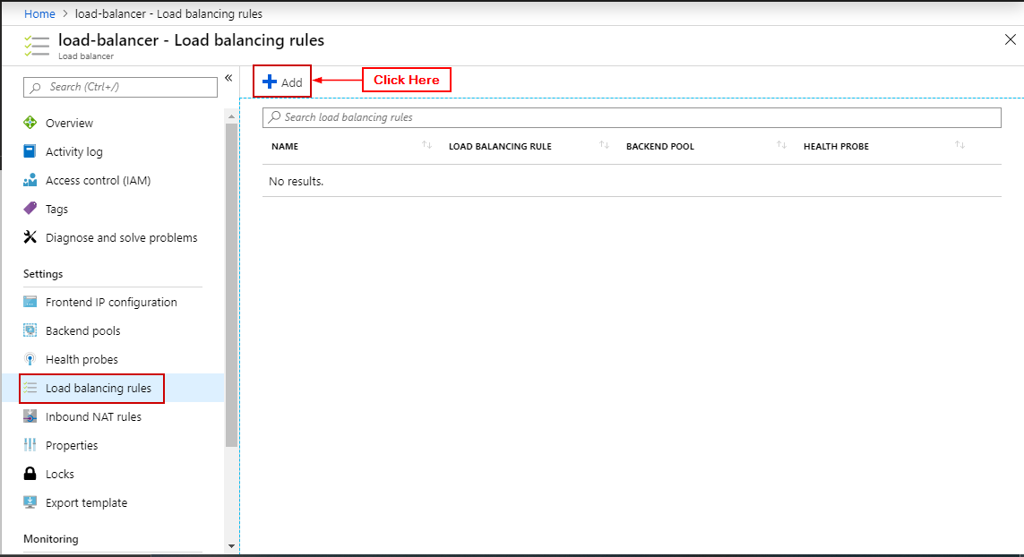

**Step 12:** Enter details click on OK.

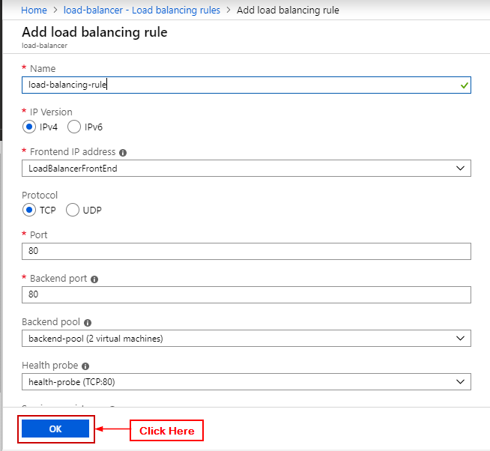

**Step 13:** Open load balancer and open the public IP Address.

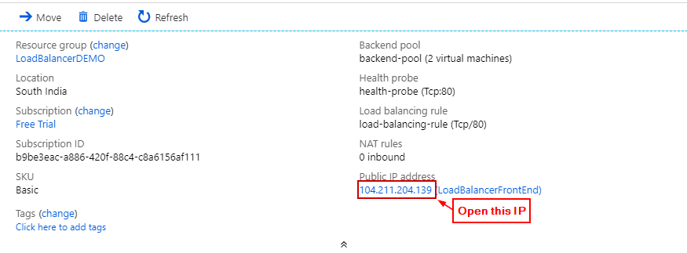

**Issue #8: They wish for you to find a way to assign and manage credentials for azure for all 10 employees in the company.**

**Solution:**

**Step 1:** In Azure Portal search for Azure Active Directory.

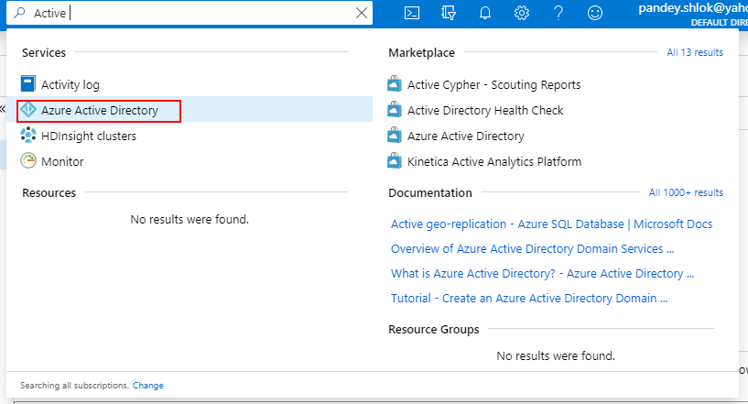

**Step 2:** Click on it and open it.

**Step 3:** In the sidebar click on Users.

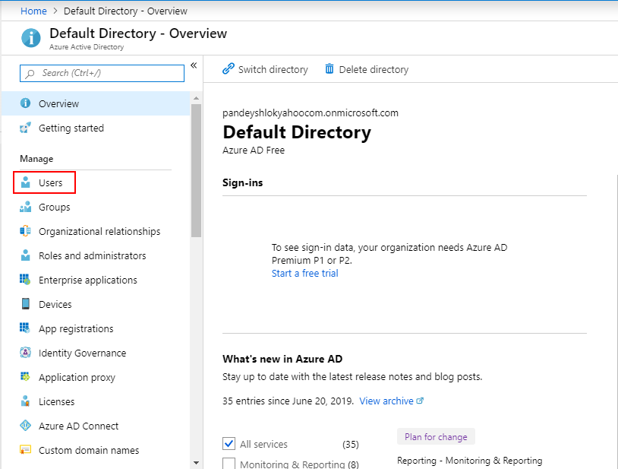

**Step 4:** Click on Bulk Create.

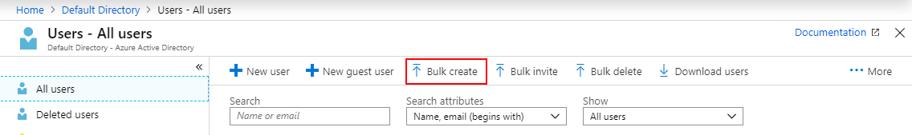

**Step 5:** Click on Download CSV Template.

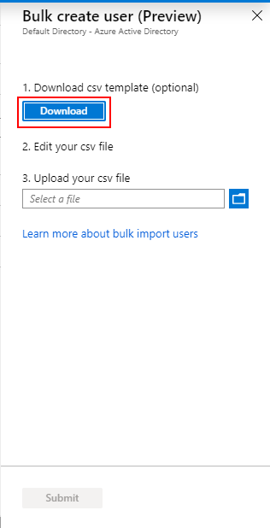

**Step 6:** Edit the CSV Template and add details of users.

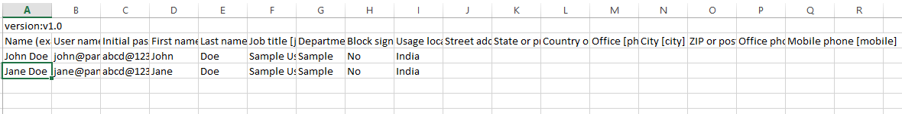

**Step 7:** Upload the CSV File.

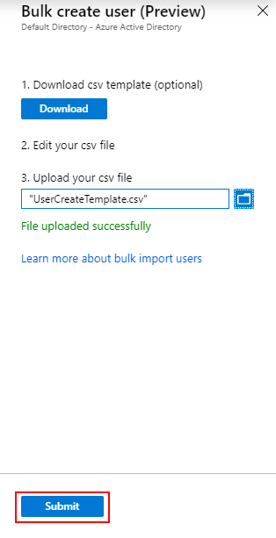

**Step 8:** Click on Submit.

**Step 9:** In the sidebar click on Bulk Operation Details to view the status.

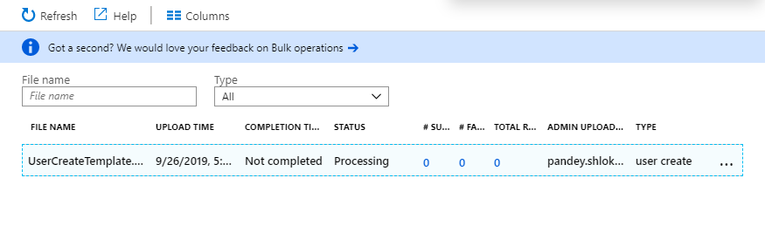

**Step 10:** After the operation is successful open the User page to view the created users.

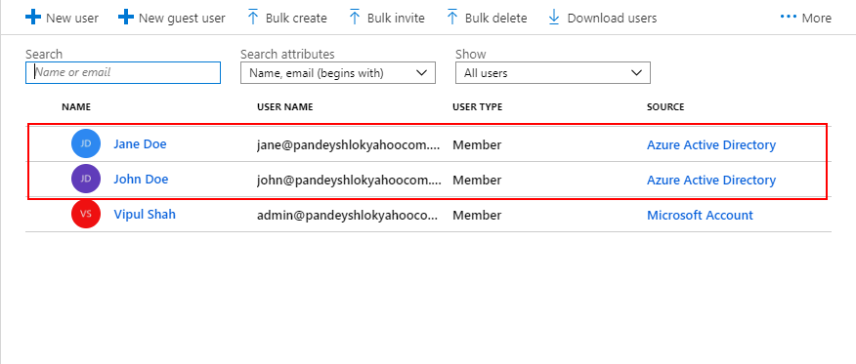

**Issue #9: Finally they have two applications that need to pass messages between one another, in an on demand basis i.e. (An application will send the message and other application will receive and process it when it can). You need to setup a service in such a way that these applications can do so, (you are provided with the code) all you need to do is make changes to the config.js file.**

**Solution:**

**-- Make sure you have node js installed and run npm install in the project directory –**

**Step 1:** Open Storage Account.

**Step 2:** Click on Queues.

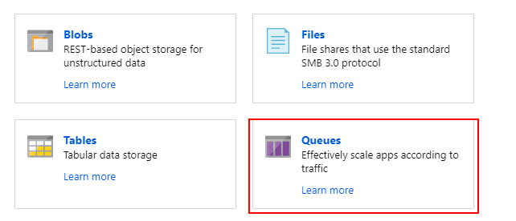

**Step 3:** Click on '+ Queue'.

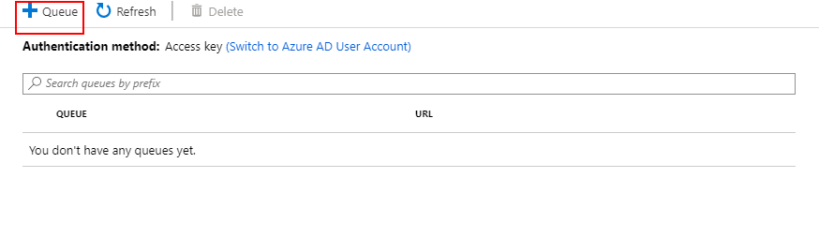

**Step 4:** Enter details and click OK.

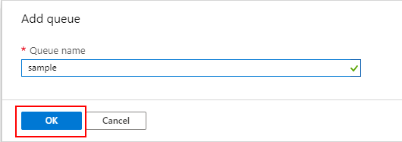

**Step 5:** Open the Storage Account.

**Step 6:** In the Settings section click on Access Keys.

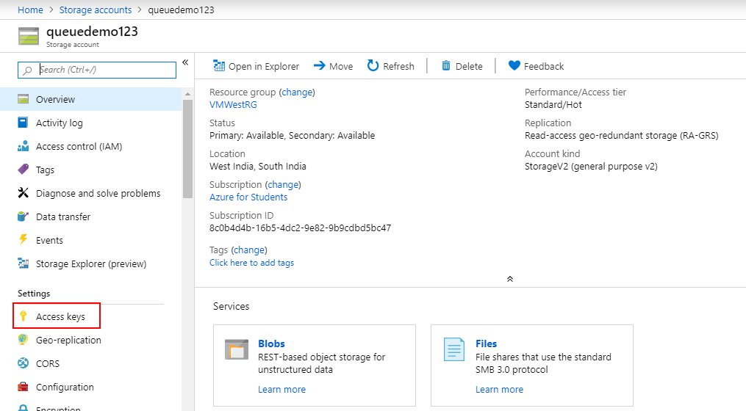

**Step 7:** Copy one of the keys.

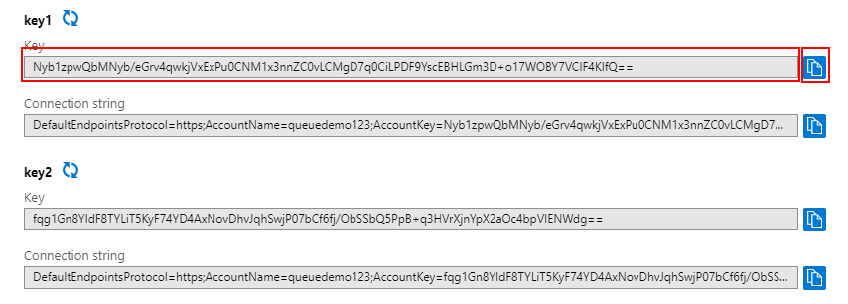

**Step 8:** Open config.js file in the sample app.

**Step 9:** Replace information:

- queueName: Name of your Queue you just created.

- azureStorageAccount: Name of your Storage Account.

- azureStorageAccessKey: Access Key for your storage account.

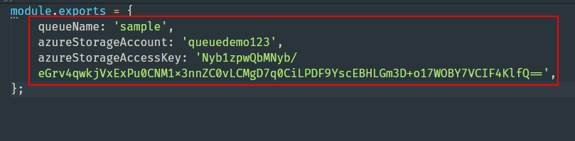

**Step 10:** Run the app the check if it works. (To run the app run the command: node server.js).

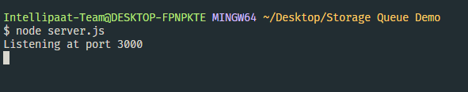

* Open <http://localhost:3000>

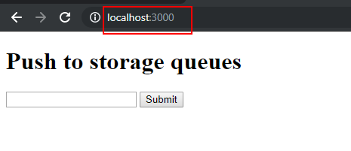

* Open <http://localhost:3000/admin>

